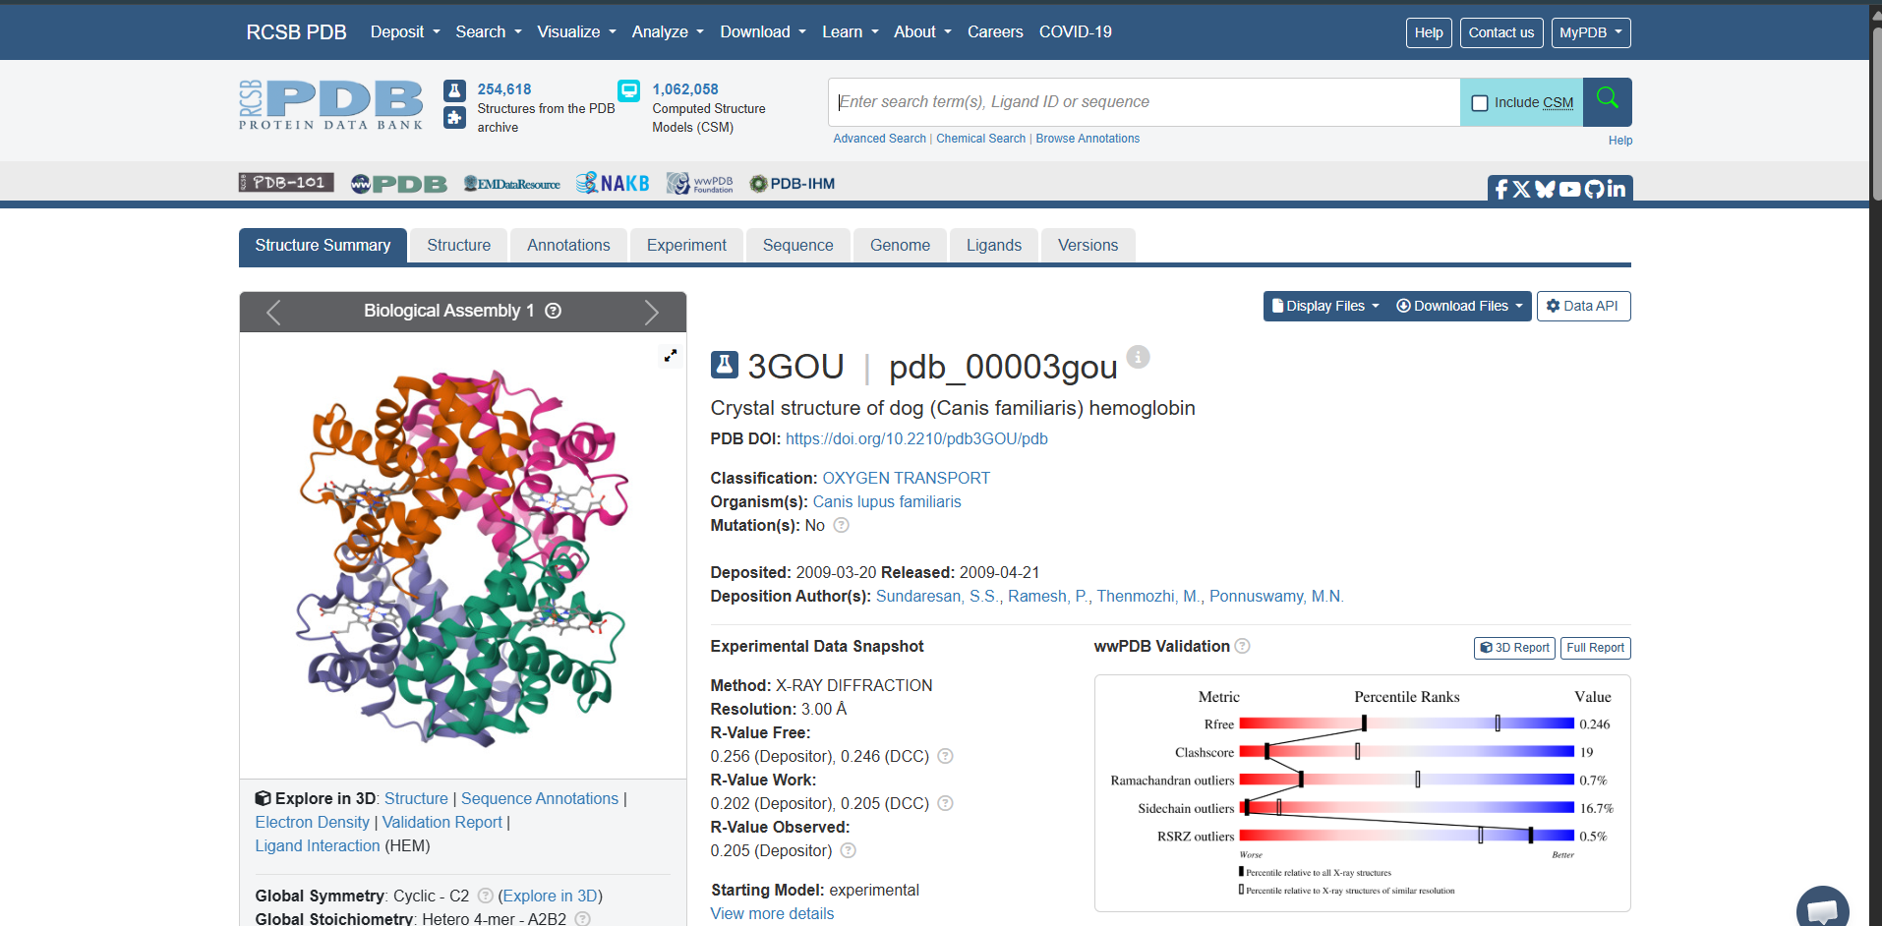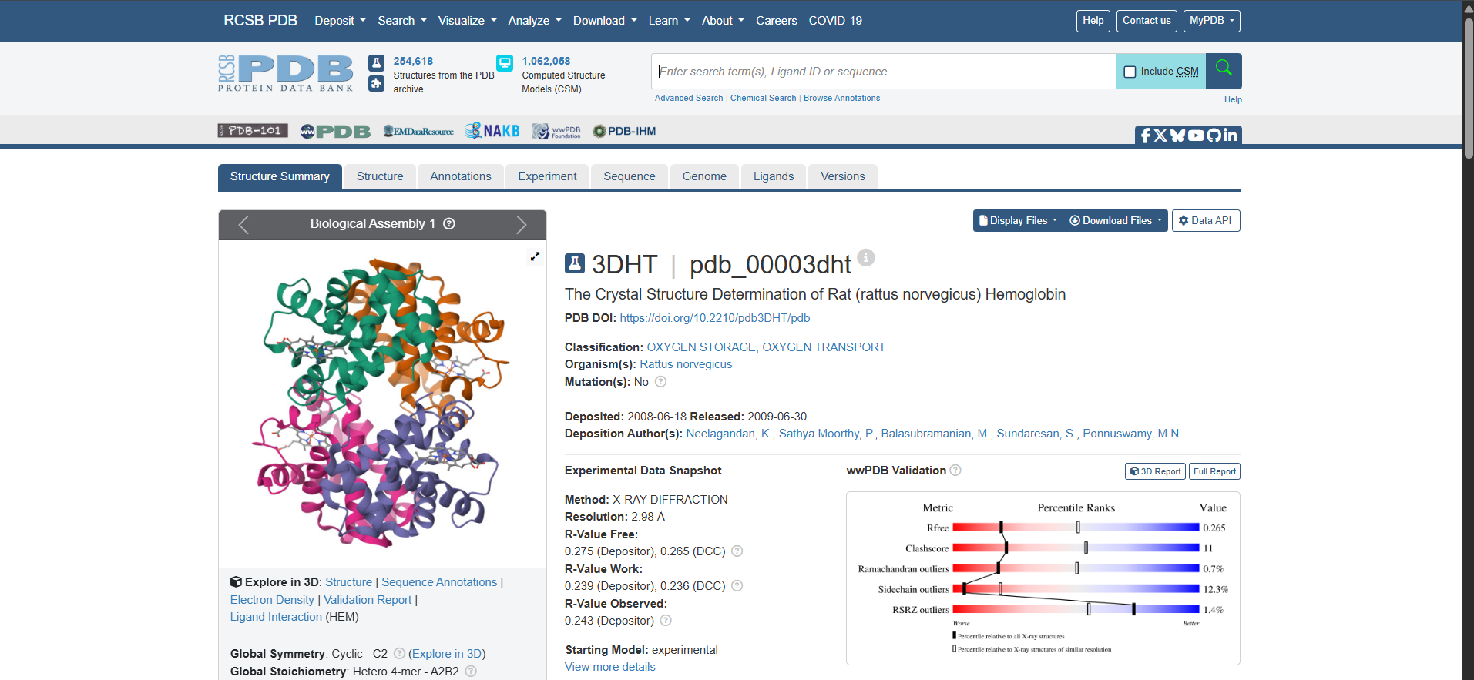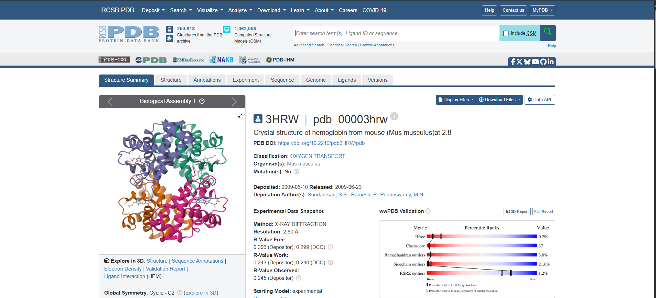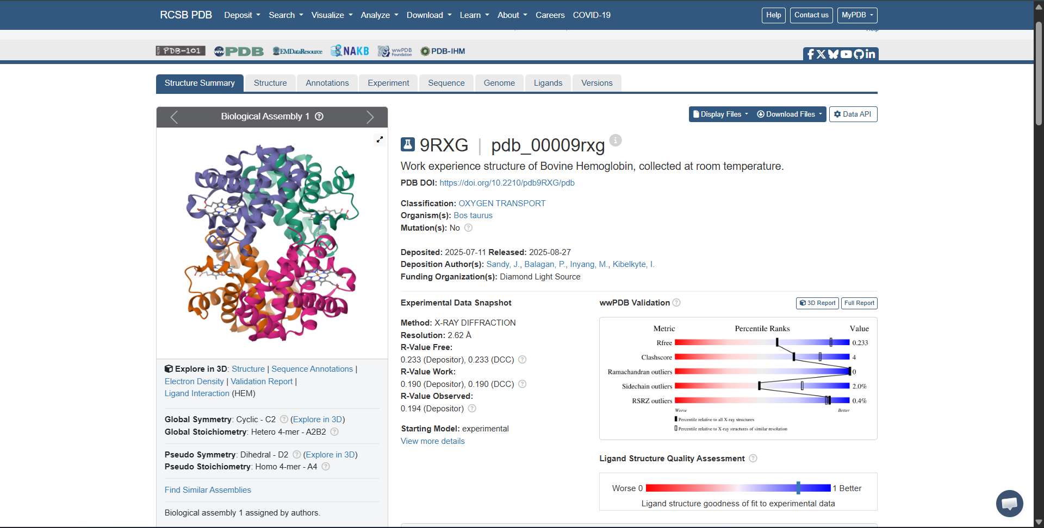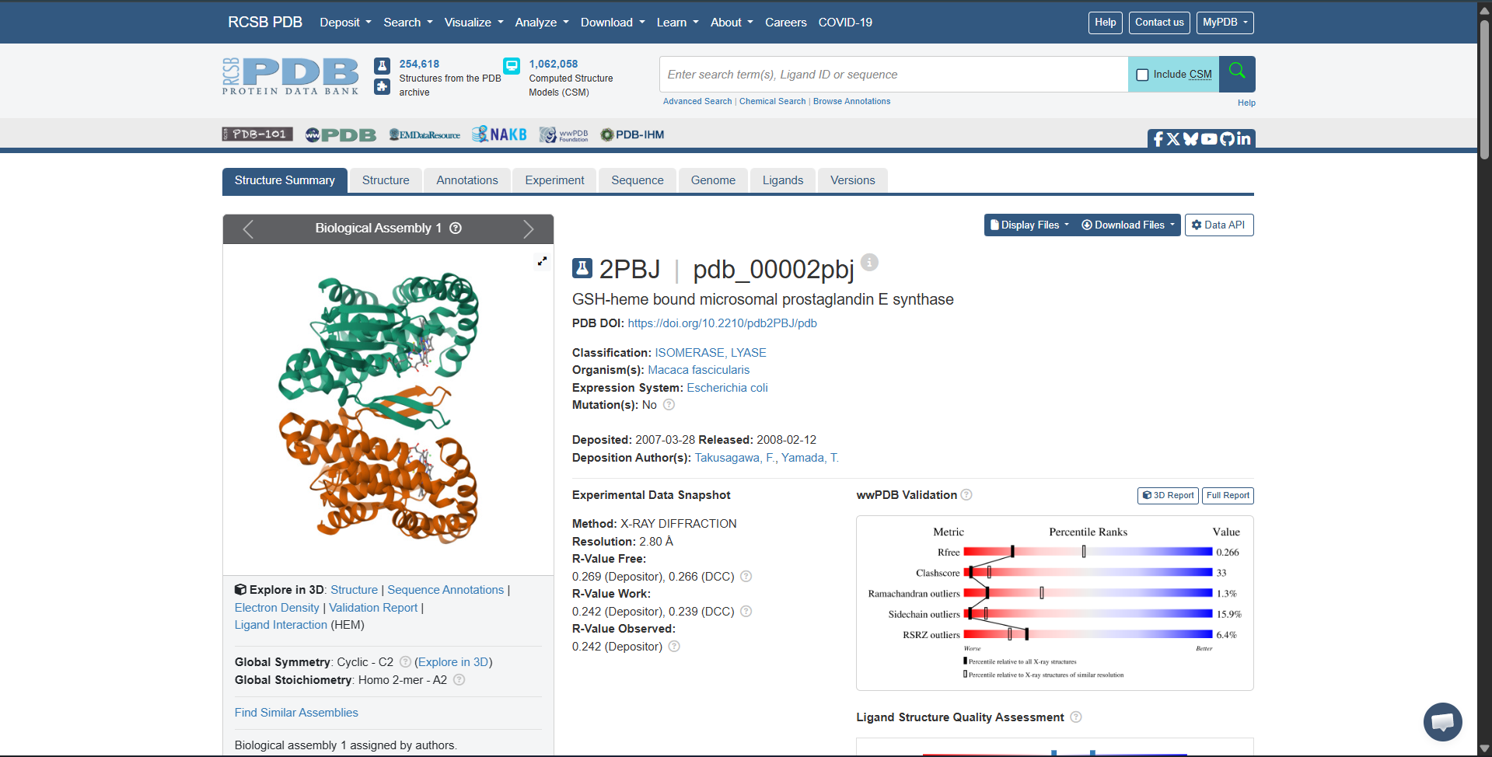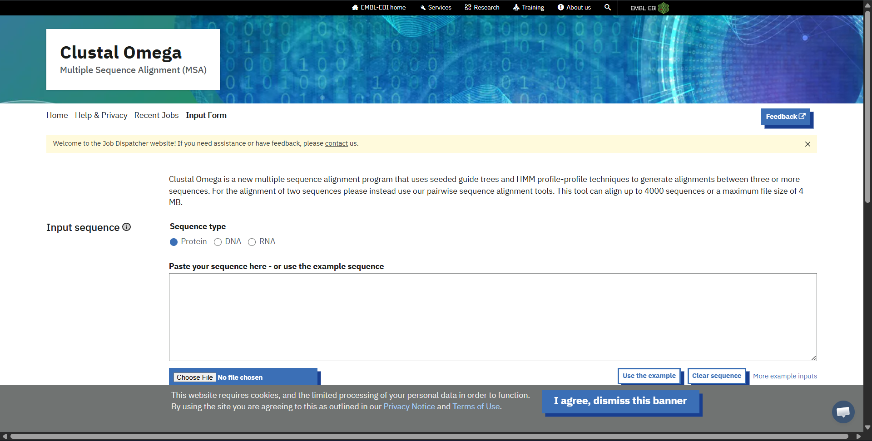
Result
CLUSTAL O(1.2.4) multiple sequence alignment

2PBJ_1|Chains ERSAVQLSLSSRLQLTLYQYKTCPFCSKVRAFLDFHALPYQVVEVNPVLRAEIKFSSYRK 60
3DHT_1|Chain ------------------------------------------------------------ 0
3HRW_1|Chains ------------------------------------------------------------ 0
3GOU_2|Chains ------------------------------------------------------------ 0
9RXG_2|Chains ------------------------------------------------------------ 0

2PBJ_1|Chains VPILVAQEGESSQQLNDSSVIISAL-----KTYLVSGQPLEEIITYYPAMKAVNDQGKEV 115
3DHT_1|Chain --VLSADD---------KTNIKNCWGKIGGHGGEYGEEALQRMFAAFPTT---------- 39
3HRW_1|Chains --VLSGED---------KSNIKAAWGKIGGHGAEYGAEALERMFASFPTT---------- 39
3GOU_2|Chains -VHLTAEE---------KSLVSGLWGKVNV--DEVGGEALGRLLIVYPWT---------- 38
9RXG_2|Chains --MLTAEE---------KAAVTAFWGKVKV--DEVGGEALGRLLVVYPWT---------- 37
* .:: .: : . : * .:: :*

2PBJ_1|Chains TEFGNKYWLMLNEKEAQQVYSGKEARTEEMKWRQWADDWLVHLI---SPNVYR------- 165
3DHT_1|Chain ------------------------------------KTYFSHID------VSPGSAQVKA 57
3HRW_1|Chains ------------------------------------KTYFPHFD------VSHGSAQVKG 57
3GOU_2|Chains ------------------------------------QRFFDSFGDLSTPDAVMSNAKVKA 62
9RXG_2|Chains ------------------------------------QRFFESFGDLSTADAVMNNPKVKA 61
. :: : .

2PBJ_1|Chains TPTEALASFDYIVREGKFGAVEGAVAK-----------------YMGAAAMYLISKRLKS 208
3DHT_1|Chain HGKKVADALAK--AADHVEDLPGALSTLSDLHAHKLRVDPVNFKFLSHCLLVTLACH--- 112
3HRW_1|Chains HGKKVADALAS--AAGHLDDLPGALSALSDLHAHKLRVDPVNFKLLSHCLLVTLASH--- 112
3GOU_2|Chains HGKKVLNSFSD--GLKNLDNLKGTFAKLSELHCDKLHVDPENFKLLGNVLVCVLAHH--- 117
9RXG_2|Chains HGKKVLDSFSN--GMKHLDDLKGTFAALSELHCDKLHVDPENFKLLGNVLVVVLARN--- 116
.:. :: :. : *:.: :. : :: .

2PBJ_1|Chains RHRLQDNVREDLYEAADKWVAAVGKDRPFMGGQKPNLADLAVYGVLRVMEGLDAFDDLMQ 268
3DHT_1|Chain ---HPGDFTPAMHASLDKFLASVST----------------------------------- 134
3HRW_1|Chains ---HPADFTPAVHASLDKFLASVST----------------------------------- 134
3GOU_2|Chains ---FGKEFTPQVQAAYQKVVAGVAN----------------------------------- 139
9RXG_2|Chains ---FGKEFTPVLQADFQKVVAGVAN----------------------------------- 138
:. : :* :*.*..

2PBJ_1|Chains HTHIQPWYLRVERAITEASPAH 290
3DHT_1|Chain -------------VLTSKYR-- 141
3HRW_1|Chains -------------VLTSKYR-- 141
3GOU_2|Chains -------------ALAHKYH-- 146
9RXG_2|Chains -------------ALAHRYH-- 145
